Secondary Website Games
Amy & Daniela
Choice Quiz Decision Making
Making a decision about your future is easy
NO
YES

NO
NO
You are likely to follow what your best friends are doing
You base your decisions on your gut feeling

You consider a variety of potential solutions before you make a decision
YES
YES

YES
NO
I am often very impulsive
You usually evaluate all the risks before taking a decision

NO
YES
NO
I prefer to make decisions on my own and let my friends know what I’m going to do

NO
NO
You get nervous very easily
I don’t like making decisions. I try to avoid it.
NO
YES
YES
YES

Aggressive
When it comes to making a decision sometimes you are quite an Aggressive decision maker! You are always ready to confront and sometimes likely to attack. Be careful! Analysing the situation or practicing a coping skill could be useful tools

Passive
When it comes to making a decision you are usually quite Passive. This means that you tend to accept or allow what happens or what others do, without active response or resistance. Be careful because each decision we take has its consequence!
Assertive
When it comes to making a decision you are usually Assertive! Well done! Being assertive means you are able to stand up for your own or other people’s rights in a calm and positive way. Assertive individuals are able to get their point across without upsetting others, or themselves.

Read more at: https://www.skillsyouneed.com/ps/assertiveness.html

Videos
Videos
(3 Videos attached)

Multiple Choice Quiz
- An Addiction refers to…
- When some takes a substance at least once in their lives.
- When someone continuously engages in a substance or an activity despite the potential harms it causes because it provides a sense of instant pleasure for the user. A strong indication of addiction is that one finds it difficult to function normally in everyday life.
- When someone has had an overdose.
- Substances are generally classified in three groups. These are:
- Stimulants, Hallucinogens, Depressants,
- Depression, Stimulations, Hallucinogens
- Hallucinogens, Medicine, Marijuana.
- Alcohol is a very common ________________ widely used around the world.
- Stimulant
- Hallucinogen
- Depressant
- LSD and Magic Mushrooms are two types of ____________________.
- Hallucinogens
- Stimulants
- Depressants
- ________________ is a powerful stimulant.
- Heroin
- Morphine
- Cocaine
- Substances like Marijuana and Prescribed Medicine cannot be classified with one particular group because...
- They are not harmful
- They contain properties from each classification
- They form part of another group
- 1 unit takes approximately___________ for the body to process
- 1 hour
- 2 hours
- 3 hours
- One of the effects of _________________ is complications in one’s reproductive system.
- Caffeine
- Morphine
- Steroids
- ________________ happens when a person takes more drugs than the body can handle.
- Infection
- Overdose
- Paranoia
- The addictive component in cigarettes is called _______________.
- Nicotine
- Ecstasy
- Marijuana

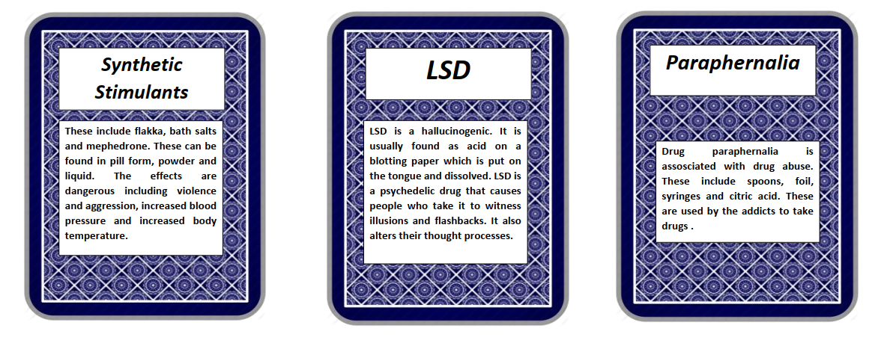
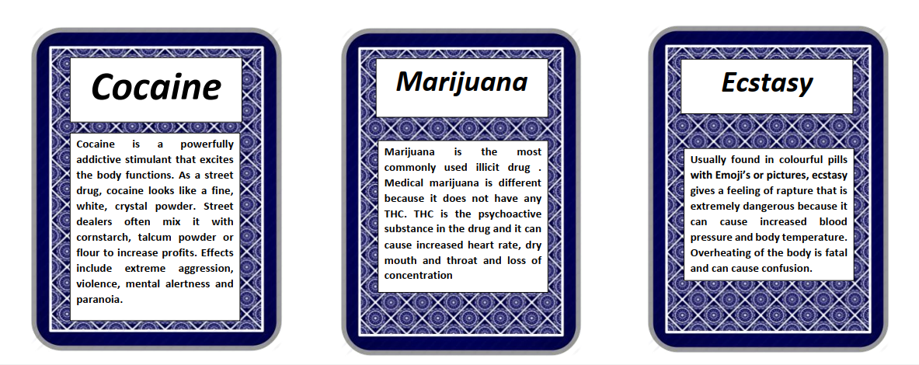
Mix & Match

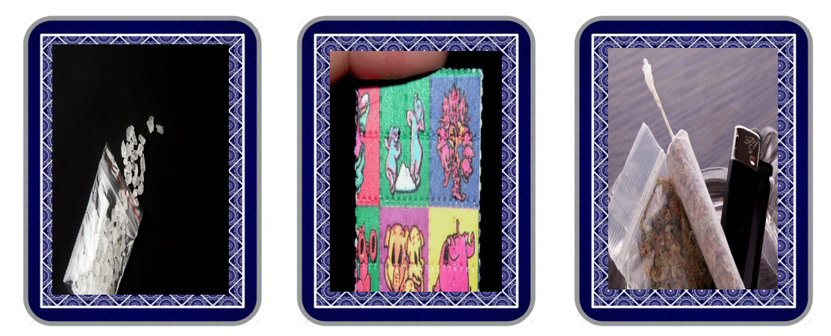
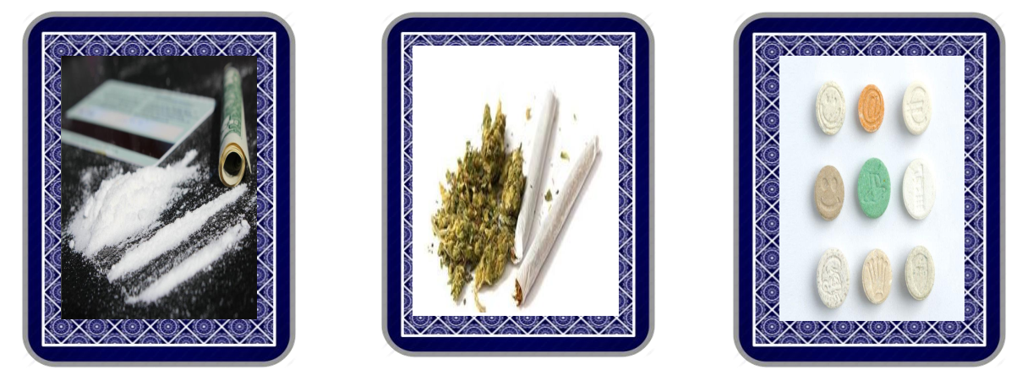
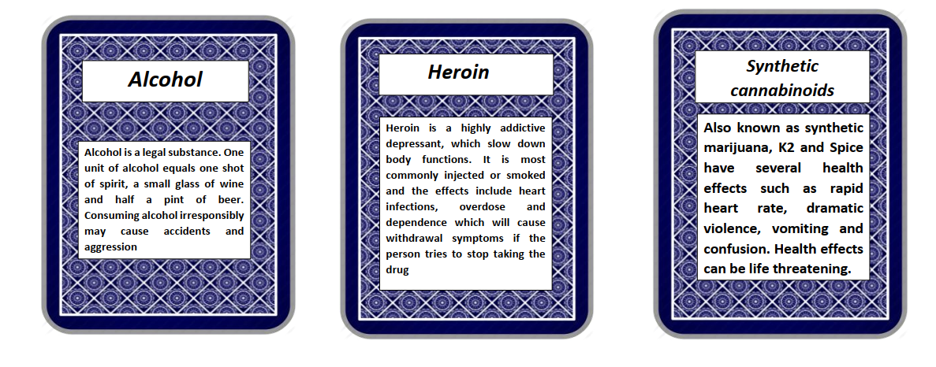
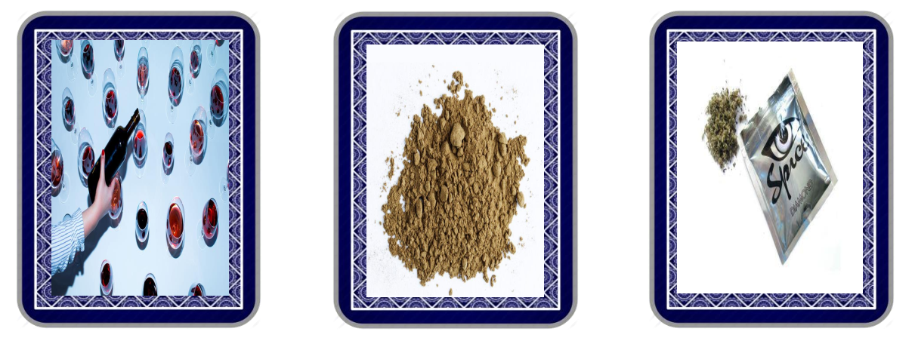
Wordsearch
  M | I | O | X | Y | K | T | S | Y | N | T | H | E | T | I | C | B | F | V | B
  P | J | C | Y | V | T | M | W | T | X | R | F | U | V | N | H | X | S | S | W
  A | H | H | C | W | B | H | W | D | X | D | O | S | F | J | F | A | B | W | Y
  Z | E | A | A | S | T | I | M | U | L | A | N | T | S | K | N | P | M | D | J
  E | X | L | F | N | P | V | L | T | F | E | A | N | V | C | D | Y | E | K | Y
  I | C | L | F | O | U | I | R | T | P | M | F | A | G | A | S | E | Z | I | F
  W | I | U | E | Z | Y | A | Y | W | L | S | X | S | I | R | G | F | S | O | Q
  H | G | C | I | M | Z | B | T | N | I | O | J | S | D | C | L | F | P | O | P
  U | A | I | N | J | A | W | I | C | Z | G | X | E | N | H | B | Y | E | K | Y
  D | R | N | E | Y | E | V | P | M | L | B | Q | R | L | E | P | N | W | Z | G
  G | E | O | Z | I | A | F | L | N | X | A | Q | P | F | R | C | Z | S | A | R
  D | T | G | H | F | K | X | H | M | N | D | R | E | K | O | B | I | K | I | E
  R | T | E | N | L | D | S | U | W | E | R | J | D | P | I | C | L | N | Q | N
  U | E | N | N | A | A | P | E | V | Z | P | M | W | I | N | H | I | I | J | E
  G | S | S | L | K | F | G | U | X | M | E | M | L | V | G | E | F | R | B | Y
  S | J | Y | K | K | O | R | V | I | X | U | T | Q | C | Q | E | R | D | D | V
  B | T | Z | M | A | C | O | C | A | I | N | E | N | P | Q | F | V | A | E | P
  P | P | F | V | C | R | R | V | V | T | D | M | H | N | C | Z | X | Y | R | H
  D | H | J | D | D | K | T | R | Y | D | R | L | L | O | H | O | C | L | A | T
  Y | Y | H | X | D | F | D | S | P | P | O | N | I | C | O | T | I | N | E | N
  COCAINE
  CRACK
  JOINT
  HALLUCINOGENS
  HEROIN
  ALCOHOL
  CIGARETTES
  SYNTHETIC
  DRUGS
  FLAKKA
  ENERGY
  DRINKS
  CAFFEINE
  NICOTINE
  STIMULANTS
  DEPRESSANTS

