DRUG USE AND ABUSE
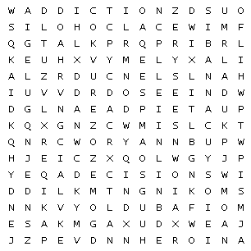

Alcohol |  | cannabis |  | cocaine
coping |  | decisions |  | dependence
drugs |  | emotions |  | heroin
LSD |  | smoking |  | talk
withdrawal

This puzzle is a word search puzzle that has a hidden message in it!

